Human Impacts on Coastal Ecosystems
Invasive Species and Disturbed Habitats

Time: 35 minutes
Group Size: 10-15 students
Grade Levels: 9th – 12th grade
Location: Maddie James Seaside Learning Center (Dock)

OVERVIEW OF ACTIVITY

Students will examine a series of settling plates and collect data regarding the abundance of organisms, biodiversity, and percent coverage. Students will then analyze their data to determine the impact of invasive and non-native species in the Dana Point harbor. Students will use this ecosystem as a model to describe the effect of physical disturbances on biodiversity and the spread of non-native organisms.

PERFORMANCE OBJECTIVES

Students will be able to:
- Identify the various organisms present on the settling plates using a field guide, and classify them as plants or animals and native or invasive.
- Calculate the abundance of individuals and the percent abundance of each species.
- Calculate the percent of presence of each species using a mini-quadrat.
- Explain the effect of biological and physical disturbances caused by humans on the biodiversity of an ecosystem.

CHALLENGE

Calculate the percent coverage and species abundance of each plate to determine the level of biodiversity and identify the presence of non-native organisms.

MATERIALS

- Wet Table on dock
- Plates from dock and quadrats
- Student data sheets
- Vis-a-vis pens
- Calculators
- Field guides
- Towels
- Shop Vac (for cleanup)

ADVANCE PREPARATION
- Set up wet table on the dock. Follow laminated instruction sheet to ensure proper setup. (Note: If wet table pumps are not working, use ice bottles from the IES locker to prevent organisms from getting too hot.)
- Remove plates from the larger framework and place in the wet table.
- Grab enough field guides, calculators, vis-à-vis pens, data sheets, hand lenses and/or large microscopes for each group.

TEACHING TIPS
- Guide students to think about how biodiversity changes through the process of succession.
- Focus on ecosystems that have experienced large scale physical disturbances where most if not all organisms are displaced and newly exposed surfaces are being settled, such as the harbor.
- Discuss how disturbed habitats can provide areas for invasive species rather than native species to settle on more easily. Invasive spp. tend to reproduce and grow quickly, have few natural predators, and can acclimate quickly to changing abiotic factors.
- Make sure students finish counting ABUNDANCE and NUMBER OF SQUARES SPECIES IS PRESENT IN before calculating percentages.
- Do not complete the student workbook with your students but give them enough information through your questioning to allow them to complete it independently.

PROCEDURE

Engage (5 minutes):
- Humans created this harbor to fulfill a need and, in the process, disrupted natural habitat. In what ways was this habitat altered from its naturally occurring state? (The jetty reduces water flow which increases water temperature, salinity, accumulation of pollution, etc. In addition, the benthic environment was highly disturbed due to dredging of the bottom to create the needed depth for boats.)
- In what ways did the change in habitat impact animal and plant life? (Much of it was destroyed, causing a “re-start” of the entire ecosystem.)
- What happens over time to biodiversity in ecosystems that experience large-scale physical disturbances from human impact? (This question should remain unanswered because this is what the students will be investigating during the activity.)

Explore (25 minutes):
- Lead the students over to the wet table and explain our ongoing settling plate research project (see Background Info above). Follow the protocol and remove the proper settling plates from the water.
- In this lab activity we are going to examine a series of settling plates. These settling plates will represent the hard surface (abiotic factor) that marine organisms settle and live on. The organisms we will observe on the plates are undergoing the natural process of repopulating a newly available surface in a disturbed ecosystem, a process called succession. Our goal is to answer the question: Does the presence of invasive species impact the biodiversity of disturbed ecosystems?
- Working in groups of 3-4, students examine each settling plate noting the Plate ID number. Each group will study ONE plate.
- Part 1: Using the Settling Organisms Field Guide, students examine their settling plate community.
- Each group of students will place a mini quadrat on their plate.
- Students identify the different organisms they find and record the species name.
- Students note whether they are plant/animal, invasive/native and record this in the appropriate place on their data sheets.
- Students count the number of organisms belonging to each species in their investigation quadrat and record this number in the ABUNDANCE section on their data sheet. TIP: To save time, have each student pick a species to count, and have everyone counting at the same time. Encourage them to count individuals square by square to keep track of organisms.
- After all species have been identified in the inspection grid, students add up the total number of different species they found (biodiversity). Then, they calculate the percent of abundance (% ABUNDANCE) for EACH species in the next column.
- Part 2: Students calculate the percent presence for each species. Please follow the procedure below.
- Each group of students should place a grid lined mini quadrat so that it is covering the entire plate.
- Going species by species, students count the NUMBER OF SQUARES SPECIES IS PRESENT IN. (Note: If a species is only just barely present in that square, tell students not to count it. Organisms should be clearly visible for it to count as “present” in that square.)
- Students will then calculate total percent of presence (% PRESENCE) for EACH species by dividing the number of squares each species is present in by the total number of squares in the quadrat (25).
- As students work through the 2 parts of this activity, encourage them to also look for any organism interactions they observe.

Explain and Extend (7 minutes):

- Use the ANALYSIS section of the Student Data Sheets to discuss species dominance and abundance for each plate. Have each group share their results. Were any of these species invasive? How do you think invasive species entered this harbor?

- After asking students to think about how invasive species enters a non-native environment, facilitate a discussion on possible solutions. Incorporate real life examples as students suggest different possible ideas.

- Based on what we have learned in this station, how would you expect the biodiversity of a disturbed ecosystem like the Dana Point Harbor to compare to a non-disturbed ecosystem, such as the Marine Refuge on the other side of the jetty? What is the limiting abiotic factor in this habitat that could affect populations of both native and invasive species?

- The presence of invasive species impact biodiversity in an ecosystem. What are some other ways that invasive species can negatively affect an ecosystem? How can their presence affect humans who rely on that ecosystem for nutrition or income?

Additional questions for advanced students:

- What factors may allow some organisms to settle on a plate 6 months after a disturbance but not immediately after a disturbance? Are native species or invasive species more likely to settle first? (Hint: Consider the life history of these species using the Field Guides.)

- About what percentage of the biota was invasive/non-native? (Answers will vary) How do you think this affects the biodiversity of native organisms? (Invasive species tend to be aggressive and out-compete native species, transforming entire ecosystems)

- There was a thriving kelp forest ecosystem off the coast of San Onofre that was highly disturbed by the construction and operation of the power plant. As a way of making amends for the destroyed ecosystem, the state ordered that the new sandy bottom ecosystem of low biodiversity was to be transformed into a much more diverse ecosystem. Artificial objects were sunk to provide surface area for settlement, creating a new reef called the Wheeler North Reef. Using the information you have just learned, what methods could we use in the harbor to transform the sandy bottom ecosystem into a more diverse ecosystem?

Evaluate (3 minutes):

- What surprised you about the data you collected on the invasive species in this habitat? Why?
- Can the presence of invasive species affect you? How and why?
- Would you eradicate an invasive species that was endangered in its native environment? Why or why not?

RECOMMENDED ASSESSMENT STRATEGY

- The ecosystem on the plates should be linked to the original rocky reef ecosystem present in Dana Point Harbor.
- Ensure that students understand that we are measuring biodiversity in species abundance (number of species per unit of space).
- As students collect their data, encourage them to look for interactions between organisms. This will be a tough objective as most interactions will be hard to notice, so use the information provided in the Field Guides.
- Every organism in the settling community, especially those that are sessile, is competing for space. This is an important interaction that most students will not see easily so the instructor should help students observe signs of competition.

ACTIVITY RESOURCES

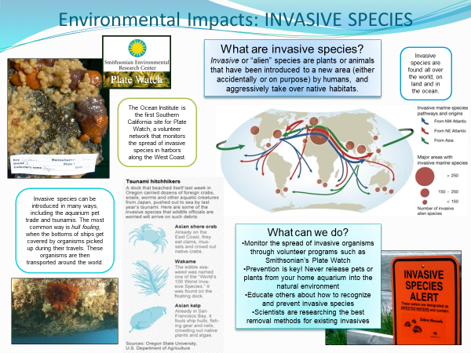
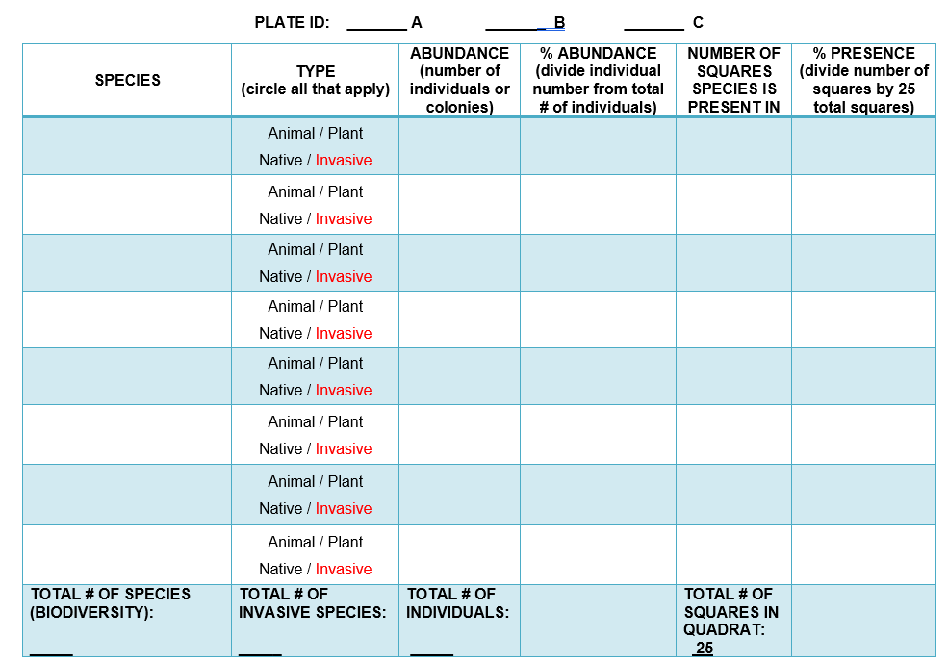

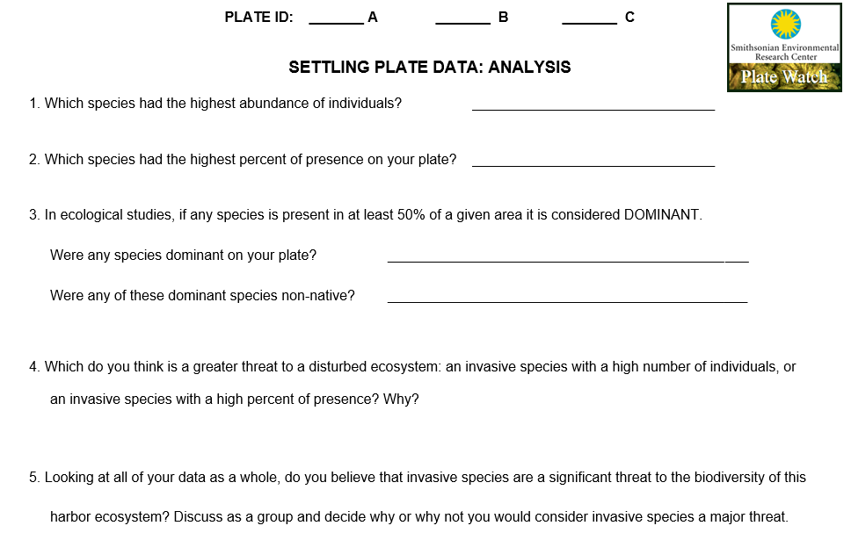
Biofouling Plate Organisms Field Guide (red box indicates invasive)
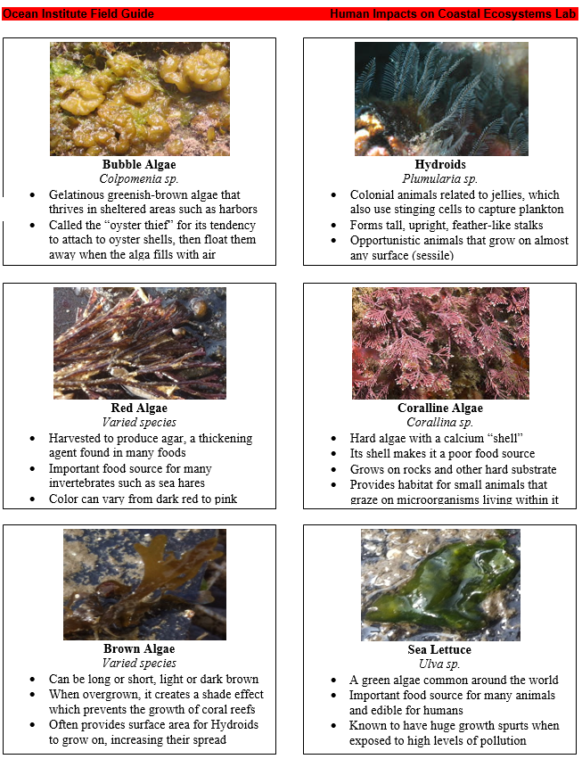
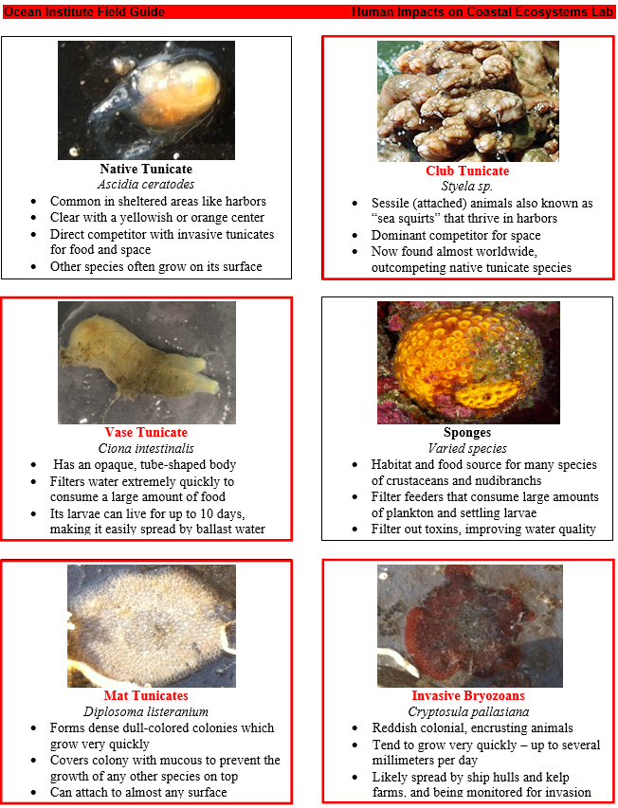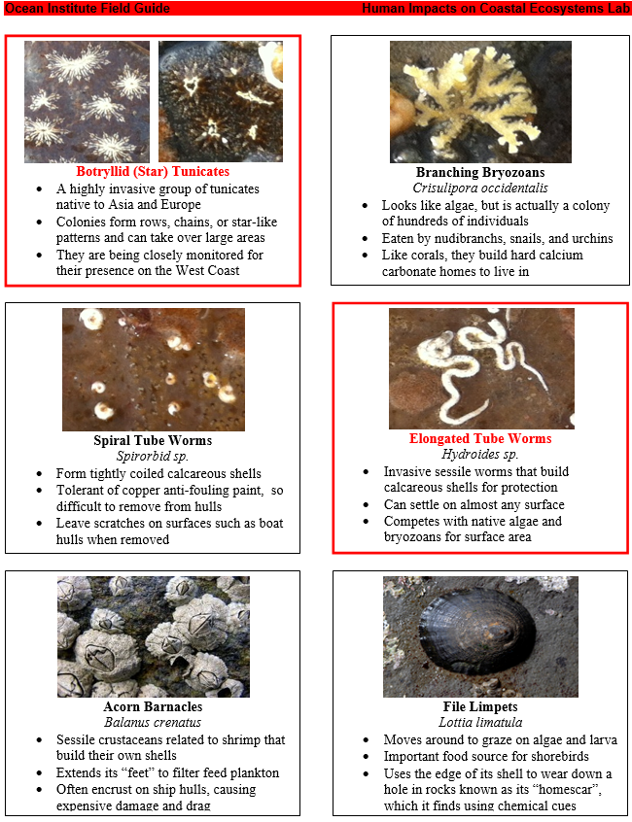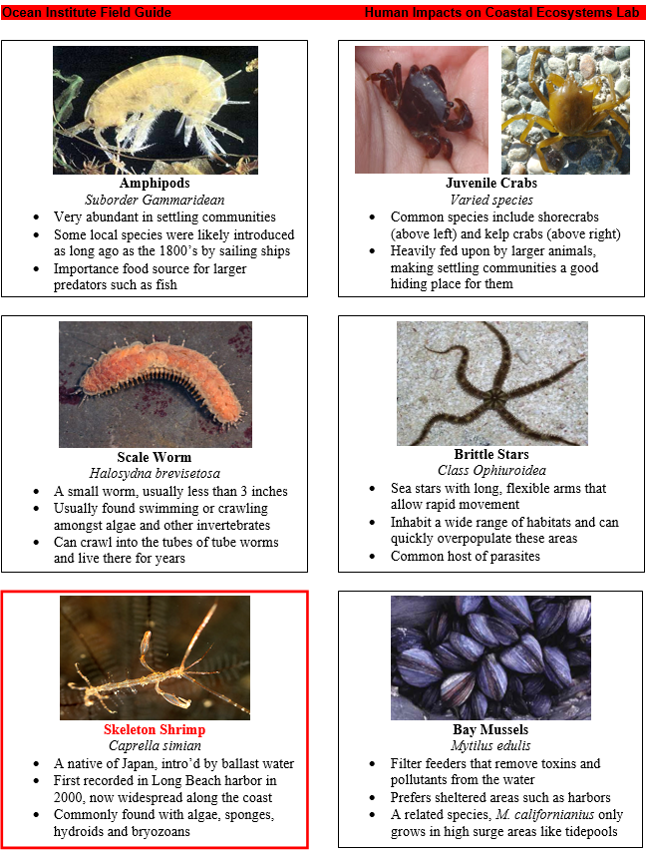

BACKGROUND INFO

Space is a highly limited resource in benthic marine ecosystems and any structure, when submerged in the ocean, provides habitat for a community of benthic marine plants and animals. This assemblage of organisms is commonly referred to as a settling community or biofouling community for the way in which it covers every inch of available space on docks, boats, and other man-made structures. A study of settling plates allows us to examine these communities to gain insight into ecological concepts such as the order of succession, interactions between organisms, resource availability and the impact of non-native species.
Ecosystems are made up of many different organisms that are interconnected through complex interactions. The biodiversity of an ecosystem is defined as the number of different organisms present in that ecosystem. While natural differences in biodiversity exist between ecosystems, many scientists look at biodiversity as an indication of the health and age of an ecosystem. Humans depend on the biodiversity of ecosystems throughout the world to provide resources such as food and medicines.
The biodiversity of ecosystems depends greatly on interactions between biotic (living) and abiotic (non-living) factors, the complexity of which has long been underestimated. Only now are scientists beginning to understand the fragile interactions that allow ecosystems to thrive. For this reason, the potential effects of human impact are often unknown until the damage is already done. The construction of the Dana Point Harbor is an excellent example of how humans can disturb natural ecosystems that have been in place for thousands of years. Other practices such as fishing, dredging, land development, and pollution can introduce unnatural biological and physical disturbances to fragile marine ecosystems. Human impacts such as these alter the balance between abiotic and biotic factors and can drastically affect water quality, organism interactions and native biodiversity.
The repopulation of ecosystems that have been drastically disturbed is known as ecological succession. Succession is defined as the pattern and sequence of population changes in a biological community that, if left undisturbed, will recover from most physical and biological disturbances and eventually reach a climax stage. For some ecosystems, such as the rocky reef ecosystem destroyed during the construction of this harbor, returning to the original biodiversity is not possible as key abiotic factors are permanently changed. The presence of the jetty reduces the flow of water and nutrients, eliminates surge from wave action, increases temperature, and collects trash and other sources of pollution. Due to these new abiotic factors, the harbor environment takes on conditions more characteristic of estuarine ecosystems and thus impacts the biotic factors.
These conditions can make harbors highly susceptible to colonization by non-native species that normally could not survive in the natural conditions of the area. In many harbors around the world invasive species make up the majority of the assemblage, destroying biodiversity and leading to extinctions. Within the continental U.S. there are approximately 500 introduced marine and estuarine species of invertebrates and algae that have established populations (National Estuarine and Marine Exotic Species Information System). A recent cost estimate for the control of invasive organisms in the U.S. (both terrestrial and aquatic species) is $138 billion per year (USDA Forest Service 2011).
From the Center for Research on Aquatic Bio-invasions: “Several mechanisms have been responsible for transporting exotic species to Pacific Coast waters. Seaweeds, sponges, barnacles, clams, worms and other organisms have traveled as "hull fouling," attached or clinging to the hulls of ships, boats or barges. A few species—including shipworms (a type of highly-modified clam) and gribbles (a group of isopods)—can bore their way into wood and traveled widely in the days of wooden ships. Other organisms have been carried with ballast, which a ship takes on to adjust the hull to a proper level in the water when there is little or no cargo aboard, and then discharges over the side when it is no longer needed. Until the late early twentieth century, ships typically used solid ballast—rocks, sand or mud—and various shoreline and intertidal plants and animals traveled along with it. Moving rocks in and out of ships is expensive, so modern cargo ships instead use large volumes of water as ballast, which carries huge numbers of phytoplankton and zooplankton (small drifting organisms) around the world.
A lot of aquaculture, in both marine and fresh water, is based on exotic species. Some of these species are planted and grown out in the environment, while others may escape from the facilities in which they are held, sometimes carrying exotic parasites or diseases. While ballast water moves a much greater number of species, aquaculture is probably a far more effective mechanism for introducing exotic parasites, diseases and other pests of fish and shellfish. For example, Pacific Coast oyster growers began importing and culturing Virginia oysters (Crassostrea virginica) from the Atlantic Coast in 1869, and Pacific oysters (Crassostrea gigas) from Japan in 1902, which resulted in many Atlantic and Japanese species (including several oyster pests) becoming established on the coast. More recent types of marine aquaculture (such as salmon and abalone farming) have also released exotic species into Pacific waters.
Other vectors include the international and cross-continental transport and sale of aquarium plants and pets, live marine bait, live seafood, and live organisms intended for use in research and teaching. It is only in recent years that there has been any general recognition of the impact of exotic species on marine waters, and the regulations and institutional arrangements needed to manage this problem have not yet been developed. Until the "biological pollution" of exotic species is regulated as rigorously as chemical pollution is, we can expect that large numbers of novel exotic species will continue to arrive on our shores.”
The Ocean Institute is an official monitoring site for PlateWatch, a volunteer network program run by the Smithsonian Environmental Research Center (SERC). Along with over 20 sites between Dana Point and Alaska, we follow established protocols and report data several times per year, which is available online to everyone in the network. The purpose of PlateWatch is to study the biodiversity of organisms that settle on plates in disturbed areas such as harbors or marinas. SERC wants to determine what invasive species are present as well as what percentage of life is made up by non-native species, to track the establishment of harmful organisms along the west coast. It is important for this data to be gathered so that regulations and mitigation procedures can be established by federal agencies. Currently in California, there are laws limiting ballast water from ships that have traveled internationally and laws concerning nuisance aquatic plants, but many scientists believe more strict laws need to be created in order to prevent a complete take-over of native biodiversity by invasive species.
To study the process of succession and the impacts of invasive species, students participating in this station will examine settling plates hung from the side of our dock for various lengths of time. The time period for which each plate has been submerged is referred to as soak time and, for our purposes, represents the time since an ecosystem has experienced a physical disturbance. It is important to realize that the plates may also be representative of the submergence of a structure for the purpose of creating an artificial reef – a means of sustaining biodiversity and increasing natural capital, such as the habitat created at Wheeler North Reef.

Real World Examples of Other Invasive Species
Lionfish (Pterois miles and P. volitans)
According to NOAA, “the Indo-Pacific lionfish (Pterois miles and P. volitans) were first detected along Florida coasts in the mid-1980s and are now well established throughout most of the Caribbean to Cape Hatteras, North Carolina. Juvenile lionfish have also been found as far north as New York and Rhode Island, though establishment and invasion north of Cape Hatteras is unlikely because lionfish cannot tolerate the cold northern waters. NOAA’s National Center for Coastal Ocean Science first documented the establishment of Indo-Pacific lionfish in the Atlantic and is leading NOAA’s efforts to study the lionfish invasion. NOAA is accomplishing its research missions on lionfish through strong collaborations with the Reef Environmental and Education Foundation (www.reef.org) and the United States Geological Survey (www.usgs.gov).
“In their native range, lionfish populations are controlled by predation, competition, and disease. In the Atlantic, Gulf of Mexico, and Caribbean they encounter few predators and are capable of reproduction year-round in warm waters. Lionfish are aggressive predators and have rapidly increased in number. Recent studies have documented significant impacts to native fish communities from lionfish predation. Lionfish occupy the same trophic position as economically important species (e.g., snapper and grouper) and may hamper native fish stock recovery efforts and coral reef conservation measures.
“NOAA is leading many research projects to assess the biology and ecology of this invasive species and to inform coastal managers of the threat and possible local control actions. Working with partners at the Aquatic Nuisance Species Task Force, NOAA is also developing a National Lionfish Management Plan. NOAA’s Office of National Marine Sanctuaries has also developed a lionfish management plan to guide the prevention, early detection, control, management, and research at the Florida Keys, Flower Garden Banks, and Gray’s Reef National Marine Sanctuaries. NOAA is also working with partners internationally to develop best management practices in the wider Caribbean region and is also organizing lionfish derbies to remove lionfish from Sanctuary waters. NOAA launched an “Eat Lionfish” campaign aimed at promoting consumption of lionfish. In partnership with the Reef Environmental Education Foundation (REEF) and others, NOAA is promoting lionfish as a sustainable seafood choice through multiple media outlets. NOAA and REEF have been partnering since 2009 to remove lionfish from the Florida Keys National Marine Sanctuary. Lionfish derbies are an effective way to raise awareness of the lionfish invasion through public participation.” Most recently, scientists have also attempted training native sharks in the area to develop a taste for lionfish in order to control the populations of these invasive species.

Cane Toad (Bufo marinus)
According to the Australian Department of Environment and Energy, “cane toads became pests after being introduced into Australia to control destructive beetles in Queensland’s sugarcane crops. Cane toads are capable of poisoning predators that try to eat them, and they continue to spread across Australia. There is no broad-scale way to control this pest, but scientists are developing a better understanding of the impacts they have on the environment and the ways in which assets, such as rare and vulnerable wildlife, can be protected.
“Cane toads are native to South and Central America. They are extremely hardy animals and voracious predators of insects and other small prey. These qualities led to their introduction into Australia as a means of controlling pest beetles in the sugar cane industry in 1935, before the use of agricultural chemicals became widespread.
“Since then, the range of cane toads has expanded through Australia’s northern landscape and they are now moving westward at an estimated 40 to 60 km per year. In Australia there are no specific predators or diseases that control cane toads. The toads can breed at any time of year but seem to prefer the weather conditions that occur with the onset of the wet season. They will lay their eggs in still or slow-moving waters. Females can lay 8,000–30,000 eggs at a time.
“The arrival of cane toads in Kakadu National Park was linked to a marked decline in some native predators in the park, especially northern quolls (Dasyurus hallucatus) and large goannas. However, based on current evidence it appears that some native predator species which are heavily impacted when toads arrive make rapid adaptations (both behavioural and physiological) allowing for population recovery in the longer term. Adult cane toads may compete with native animals, particularly for shelter. For example, a 2004 study showed that cane toads ruined one-third of nest attempts of ground-nesting rainbow bee-eaters by usurping their nest burrows and preying upon their eggs and young nestling.

“It is possible to control cane toad numbers humanely in a small area, such as a local creek or pond. This can be done by collecting the long jelly-like strings of cane toad eggs from the water or by humanely disposing of adult cane toads. Control is best at the egg or adult stages because cane toad tadpoles can easily be confused with some native tadpoles. This approach to cane toad control requires ongoing monitoring of the creek or pond. Fine-mesh fencing can also assist in keeping cane toads from ponds that are in need of special protection.
“Researchers are beginning to understand the toad’s impact on native fauna and to appreciate the ways in which native species are adapting to the presence of cane toads and recovering from the impact of their arrival. Protecting our most vulnerable native species on a local scale is the focus of current planning around cane toads. The Australian Government is preparing a threat abatement plan to set out the research, management and other actions necessary to reduce the key threatening process concerned to an acceptable level in order to maximize the chances of long-term survival in nature of native species and ecological communities affected by cane toads.”

Galapagos Goat (Capra hircus)
According to www.nature.com, “the Galapagos Islands that fired Charles Darwin's imagination are both a hotbed of biodiversity and extremely vulnerable to invasive species. The largest eradication of a mammal species from an island ever achieved was reported. All 80,000 or so goats (Capra hircus) on the 58,500-hectare Santiago Island were eradicated in just 52 months. Goats [had been] successfully introduced to Santiago Island, which sits in the middle of the Galapagos archipelago, over the 1920s and 1940s. The goats grazed the island mercilessly, causing erosion, threatening the survival of rare plants and trees and competing with native fauna, such as giant tortoises.”
A group of scientists recruited local residents to cull these invasive goats. The goats were first herded into corrals by people on horseback wielding air horns and firing rifles. The captured goats were then killed humanely. Other goats were hunted on foot, with the help of dogs or by a large group hunting together in a line, combing the island. But the goats proved difficult to eradicate. After various attempts, the teams decided to use helicopters to help them spot and kill the animals. This attempt was 90% successful. To eradicate them fully, the final stage involved using 'Judas' goats and 'Mata Hari' goats. The Judas goats were goats that had been captured from nearby islands and then released with radio collars to lead hunters to the last few goats. 'Mata Hari' goats — sterilized female Judas goats that were injected with hormones to simulate females in heat — helped to lure out otherwise wary male goats.
The island has been monitored since 2005 and now seems to be goat free. The eradication effort cost a total of $6.1 million dollars, but more than one-third of that was spent on eradicating the last 1,000 goats and monitoring to make sure the job was done.
As the goats disappeared, the plant life on Santiago bounced back, including some invasive plants such as blackberry (Rubus niveus). Control efforts are under way to weed them out. Meanwhile, native plants are also flourishing, and birds, such as the Galapagos rail (Laterallus spilonotus) have returned as well.

Other Resources/Articles:
- https://qz.com/741055/machine-gunning-goats-from-helicopters-is-just-one-way-to-stop-the-spread-of-invasive-species/ (Lionfish, Cane Toad, Galapagos Goats – Summary)
- https://www.livescience.com/29560-cane-toad-conquest-invades-australia.html (Cane Toad)
- http://www.environment.gov.au/biodiversity/invasive-species/publications/factsheet-cane-toad-bufo-marinus (Cane Toad)

VOCABULARY
- Biofouling – the process of species settlement on hard surfaces, usually associated with unnatural surfaces such as boat hulls and buoys
- Sessile – attached permanently to a hard surface
- Climax Community – an assemblage of animals that has been established so long, the biodiversity and species abundance is generally unchanging
- Invasive Species – a species not native to local ecosystems that tends to overcrowd or outcompete native species
- Species Abundance – the number of individuals of a species present in a given area
- Biodiversity – the amount of variety of different species present in a given area
- Biotic – living factors of an ecosystem
- Abiotic – non-living factors of an ecosystem
- Disturbance – a natural or human-caused event that impacts the health and biodiversity of an ecosystem
- Succession – the pattern of species settlement and abundance in a given area over time
- Quadrat – A tool used by scientists for ecological studies, containing many smaller squares that can be used for counting organisms

Helpful Resources:
Plate Watch at the Smithsonian Environmental Research Center - http://platewatch.nisbase.org/
The Center for Research on Aquatic Bio-invasions - Guide to non-native marine species of the Pacific Coast: http://www.exoticsguide.org/
A full list of laws and regulations concerning invasive species in California - http://www.invasivespeciesinfo.gov/laws/ca.shtml
A good overview of invasive species from the California Department of Fish and Wildlife - http://www.dfg.ca.gov/invasives

NOAA Habitat Conservation and Aquatic Invasive Species - http://www.habitat.noaa.gov/restoration/programs/invasivespecies.html

“Biofouling: It’s not just barnacles anymore.” http://www.csa.com/discoveryguides/biofoul/overview.php

“Succession in a Humboldt Bay marine fouling community: the role of exotic species, larval settlement and winter storms.” http://www.humboldt.edu/biosci/faculty/documents/BoyleCraig.pdf

